DATA ANALYSIS INTERNSHIP – DAY 19 REPORT
Organization: Top Tech Developers
Topic Covered: Power BI Query Editor – Rows, Columns, Split Column, Group By, Pivot, Parse, and Fill Functions

Introduction
Microsoft Power BI Query Editor is an important tool used for data cleaning, transformation, and preparation before creating dashboards and reports. It helps convert raw datasets into organized and structured formats for accurate analysis and visualization.
On Day 19 of the internship, different Power Query Editor operations such as row operations, column transformations, split column methods, Group By, Pivot Column, Parse functions, and Fill functions were learned and implemented successfully.

Topics Covered

1. Row Operations
Different row operations were performed using Power Query Editor.
Operations Practiced
- Remove Rows
- Remove Top Rows
- Remove Bottom Rows
- Remove Blank Rows
- Remove Alternate Rows
- Keep Rows
Purpose
- Removes unnecessary or unwanted records
- Cleans datasets before analysis
- Improves data quality and readability
Observation
- Row operations helped remove duplicate and empty records
- Cleaned datasets became easier to analyze and visualize
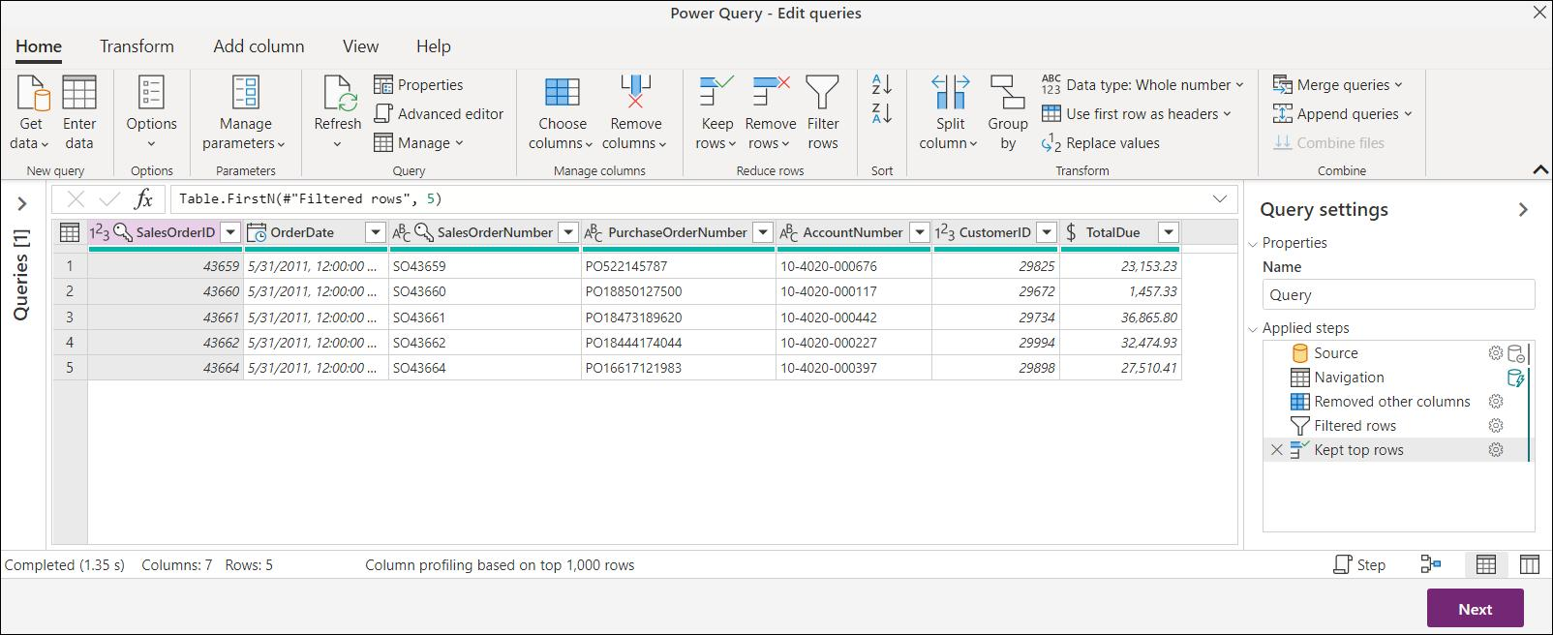
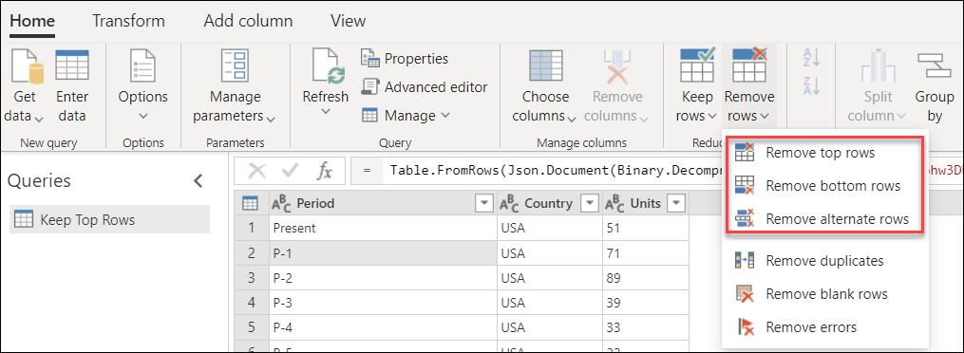
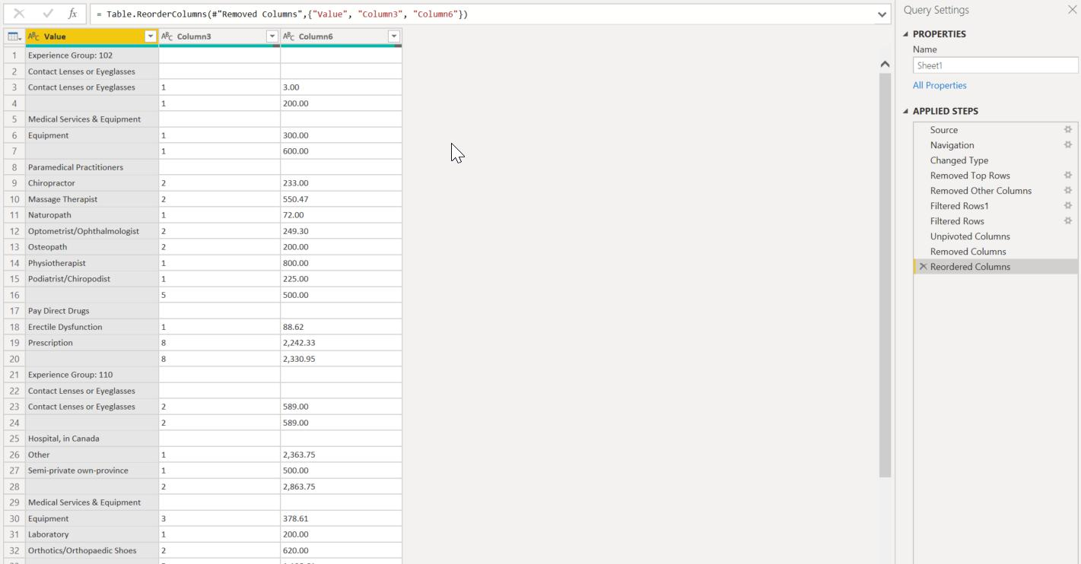

2. Column Operations
Different column transformation techniques were explored.
Operations Practiced
- Rename Column
- Remove Column
- Duplicate Column
- Change Data Type
- Move Columns
- Merge Columns
Purpose
- Organizes dataset structure properly
- Improves column readability
- Helps prepare datasets for analysis and reporting
Observation
- Column transformations improved dataset organization
- Proper data types reduced analysis errors

3. Split Column
The Split Column feature was used to divide combined data into multiple columns.
Split Methods Used
- Delimiter (comma, space, hyphen, etc.)
- Number of Characters
- Positions
- Uppercase to Lowercase Transition
- Digit to Non-Digit Transition
Purpose
- Separates combined values into structured columns
- Useful for names, IDs, dates, and product codes
Observation
- Split Column improved data formatting and structure
- Combined data became easier to analyze separately
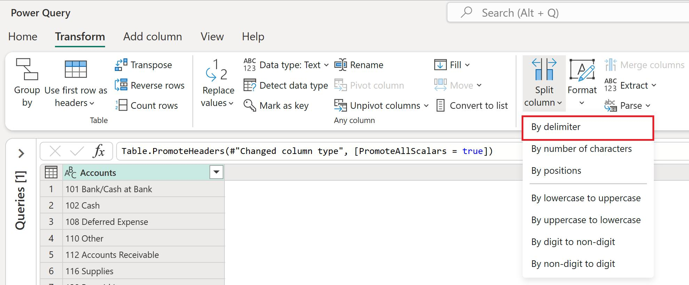
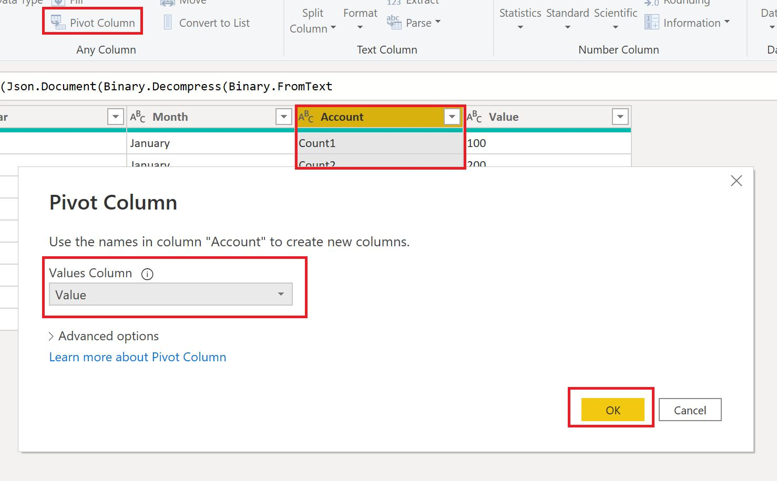
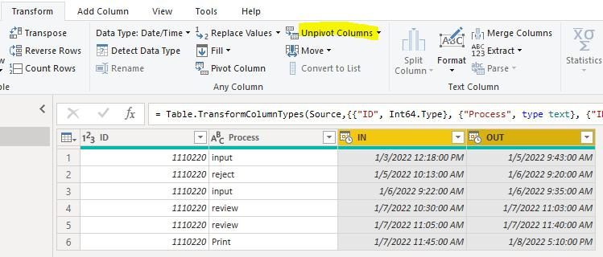
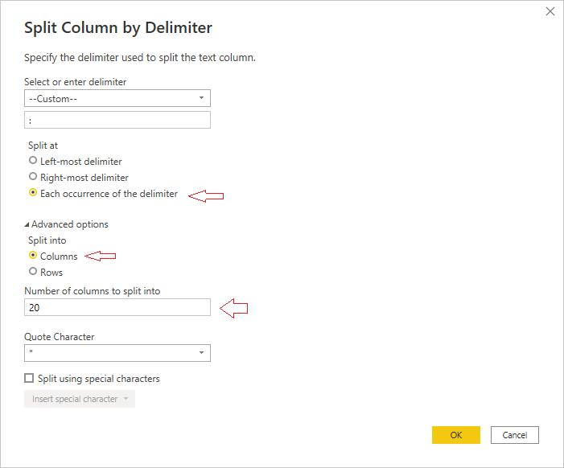
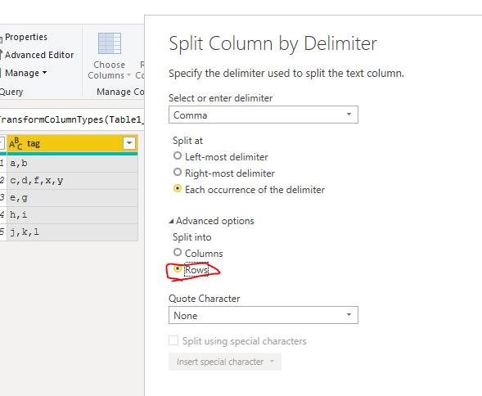
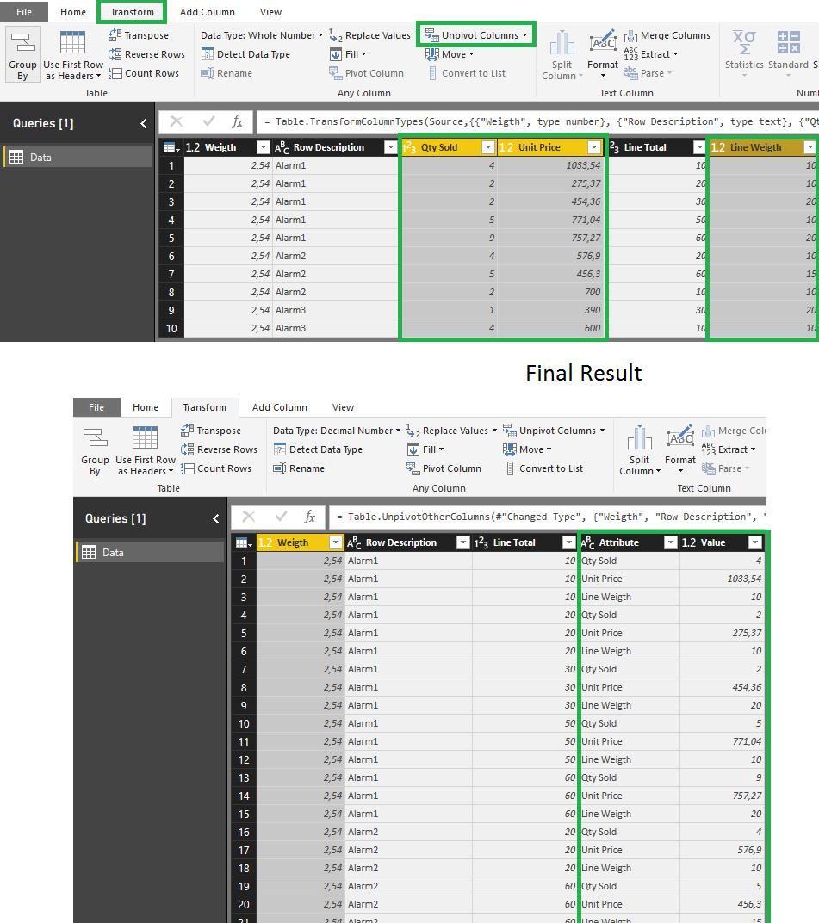
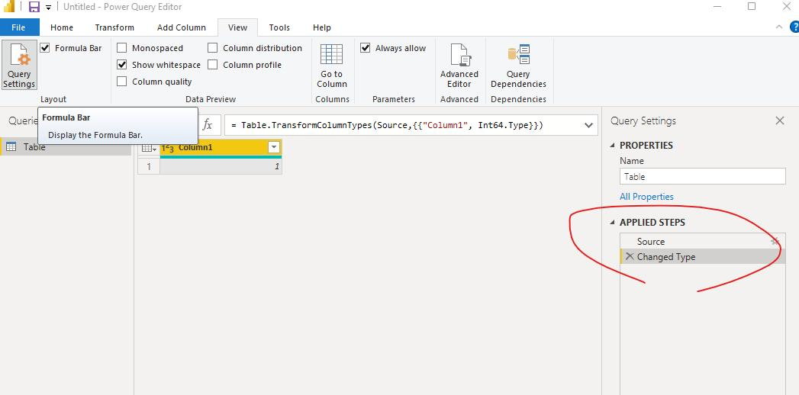

4. Group By Function
The Group By feature was used for data summarization and aggregation.
Functions Used
- Sum
- Count
- Average
- Minimum
- Maximum
Example
Revenue values were grouped based on:
- Product
- Region
- Category
Purpose
- Creates summarized business reports
- Helps analyze grouped business data
Observation
- Group By simplified large datasets into summarized insights
- Aggregated values improved business analysis

5. Pivot Column
The Pivot Column feature was used to convert row values into separate columns.
Example
Monthly sales values stored in rows were converted into separate month columns.
Purpose
- Creates summary tables
- Improves data readability
- Simplifies comparison and reporting
Observation
- Pivot transformation improved report structure
- Monthly comparisons became easier to analyze

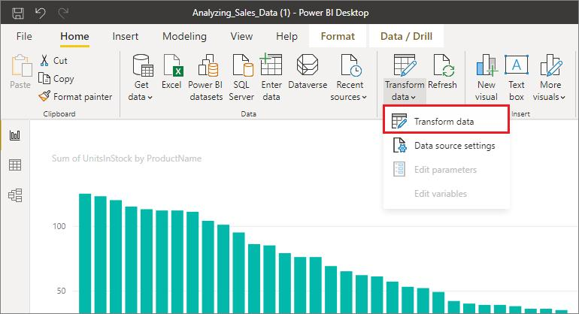
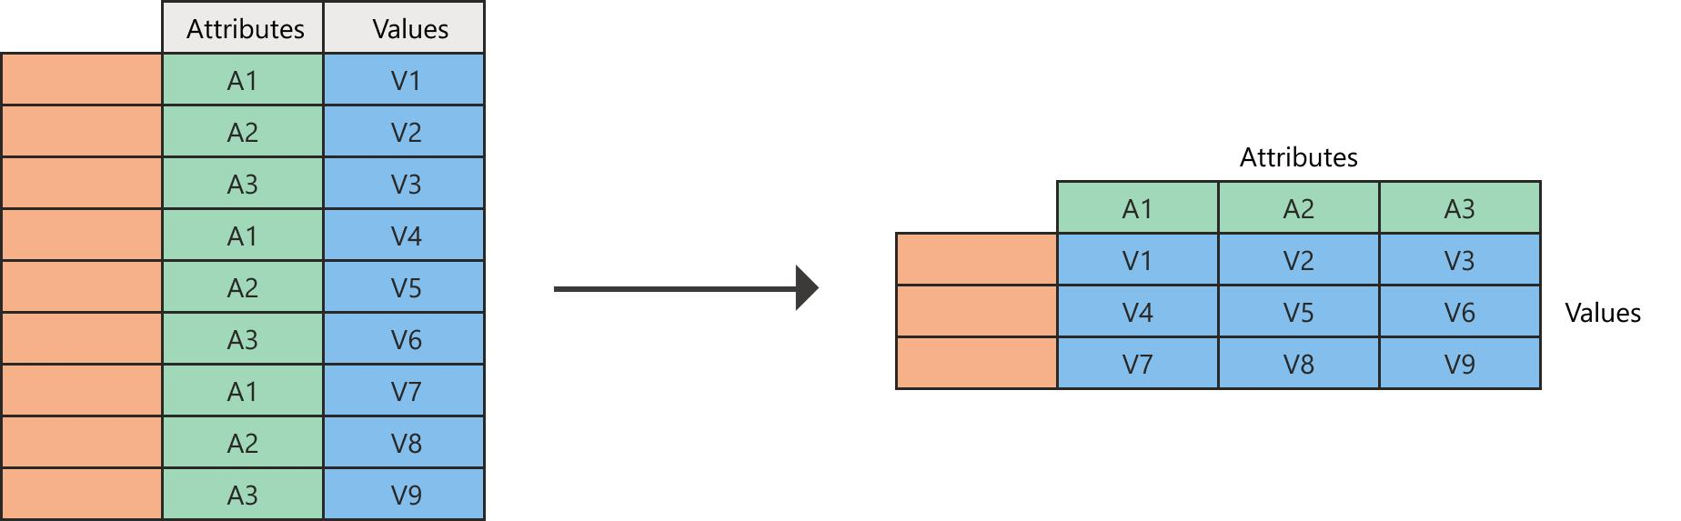
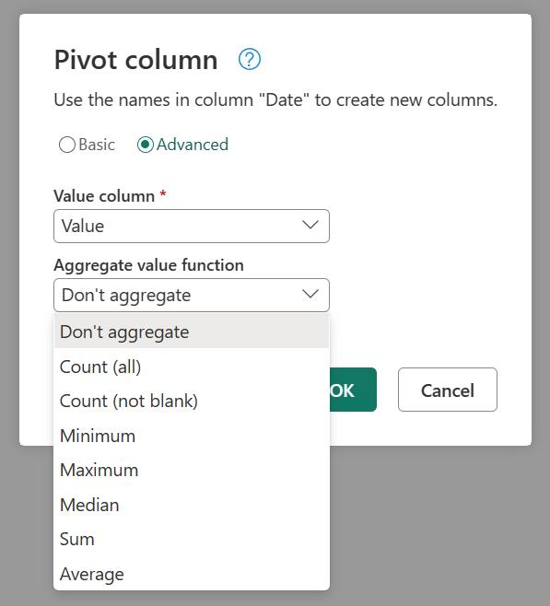
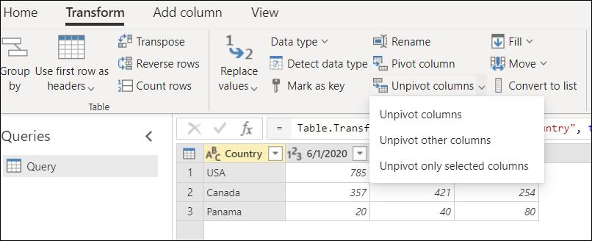
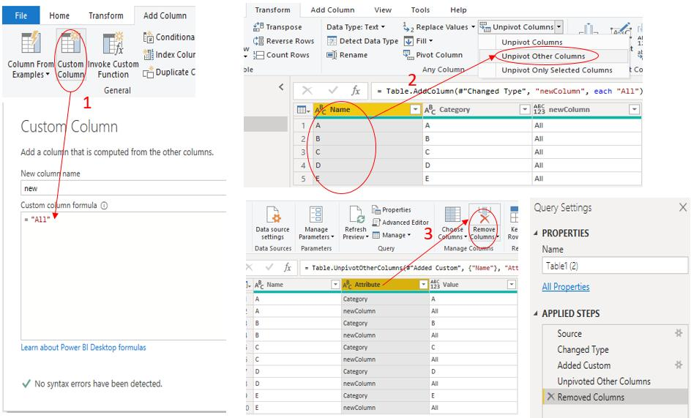

6. Parse Function
The Parse function was used to convert raw or unstructured data into readable formats.
Examples
- Parsing date values into proper date format
- Converting imported raw data into structured columns
Purpose
- Converts unstructured data into usable format
- Prepares datasets for reporting and dashboards
Observation
- Parse functions improved data accuracy and formatting
- Structured datasets improved analysis efficiency

7. Fill Function
The Fill function was used to replace blank or null values automatically.
Types Used
- Fill Down
- Fill Up
Purpose
- Replaces empty values automatically
- Maintains dataset consistency
Observation
- Fill operations reduced missing value problems
- Dataset completeness improved significantly
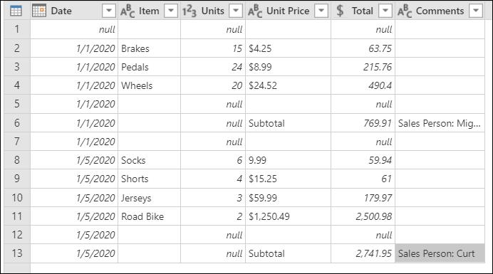
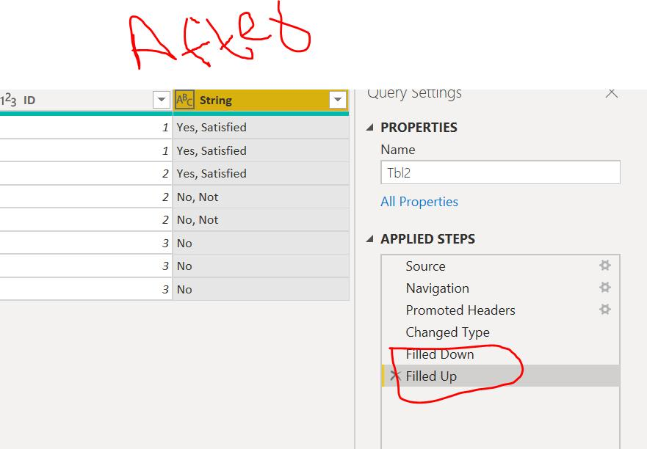
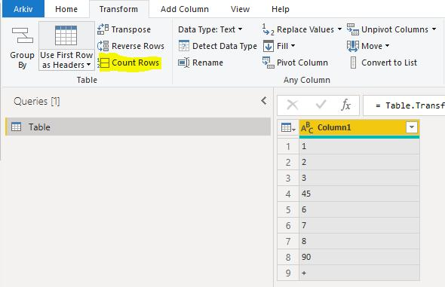

Tools Used
- Microsoft Power BI
- Power Query Editor
- Data Cleaning
- Data Transformation
- Business Intelligence

Outcome
The Power Query Editor operations were implemented successfully for:
- Data cleaning
- Data transformation
- Data formatting
- Data summarization
These techniques improved dataset organization and prepared the data effectively for dashboards and reports.

Learning Outcome
On Day 19, I learned how to use Power Query Editor for data preparation and transformation.
I understood:
- how to perform row and column operations
- how to split and merge columns
- how to summarize data using Group By
- how to transform rows into columns using Pivot
- how Fill functions handle missing values
- how data cleaning improves dashboard accuracy

Conclusion
The Day 19 internship session helped me understand practical data cleaning and transformation techniques using Microsoft Power BI Query Editor.
Different operations such as row removal, column transformations, split columns, Group By functions, Pivot Columns, Parse functions, and Fill operations were implemented successfully. These techniques improved dataset quality, organization, and reporting efficiency. This session enhanced my practical understanding of data preparation and business intelligence workflows in Power BI.

